# Difference between invoking web service using C# and jQuery.

Invoking using C#.

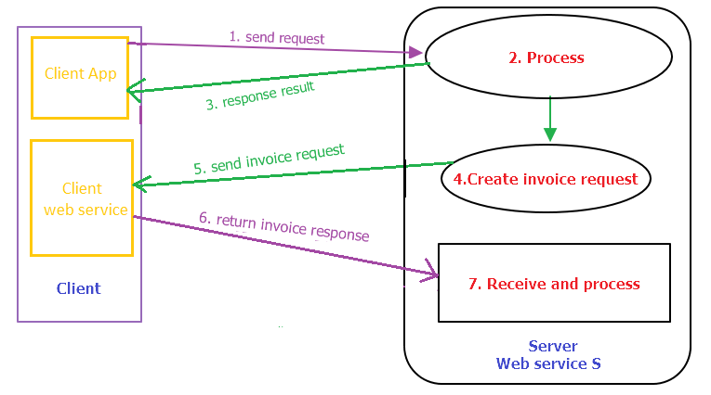

Invoking using jQuery.

